


Computer Communications 26 (2003) 351–365

www.elsevier.com/locate/comcom

Abstract

Proﬁle-based routing and trafﬁc engineering

Subhash Suriª, Marcel Waldvogel^{b,}*, Daniel Bauerb, Priyank Ramesh Warkhede^{c}
aDepartment of Computer Science, UC Santa Barbara, 2111 Engineering I, Santa Barbara, CA 93106, USA
bIBM Zurich Research Laboratory, 8803 RuЁschlikon, Switzerland
cCisco Systems, San Jose, CA 95134, USA
Received 12 May 2002; accepted 14 May 2002

We present a new algorithm and framework for dynamic routing of bandwidth-guaranteed ﬂows. The problem is motivated by the need to
set up bandwidth-guaranteed paths in carrier and ISP networks dynamically. Traditional routing algorithms such as minimum-hop or widest-
path routing do not take advantage of any knowledge about the trafﬁc distribution or ingress – egress pairs, and therefore can often lead to
severe network underutilization. Our work is inspired by the recently proposed Minimum Interference Routing Algorithm (MIRA) of
Kodialam and Lakshman, but it improves on their approach in several ways. Our main idea is to use a ‘trafﬁc proﬁle’ of the network, obtained
by measurements or service-level agreements as a rough predictor of the future trafﬁc distribution. We use this proﬁle to solve a multi-
commodity network ﬂow problem, whose output is used both to guide our online path-selection algorithm as well as to impose admission
control. The ofﬂine multi-commodity solution seems very effective at distributing the routes and avoiding bottlenecks around hot spots. In
particular, our algorithm can anticipate a ﬂow’s blocking effect on groups of ingress – egress pairs, whereas, MIRA only considers one
ingress – egress pair at a time. Our simulation results show that the new algorithm outperforms shortest-path, widest-path, and minimum
interference routing algorithms on several metrics, including the fraction of requests routed and the fraction of requested bandwidth routed.
Finally, the framework is quite general and can be extended in numerous ways to accommodate a variety of trafﬁc management priorities in
the network.
q 2002 Elsevier Science B.V. All rights reserved.
Keywords: Routing; Flow routing; Proﬁle; Label switching; Multi-protocol label-switched; Trafﬁc engineering

1. Introduction

We present a new algorithm and framework for dynamic
routing of bandwidth-guaranteed ﬂows. Our algorithm is
online, meaning that it routes requests one at a time, without
speciﬁc knowledge of future demands. We use quasi-static
information about the network and trafﬁc to select paths so
as to minimize the number of requests that are rejected or
the network bandwidth that is wasted. Clearly, if no
assumptions are made about the ﬂow requests, a pathologi-
cally chosen set of requests can foil any online algorithm.
We make minimal assumptions that are justiﬁable in
practice and lead to a signiﬁcant improvement in network
utilization. In particular, we assume that the ingress and
egress nodes in the network are known, and that a trafﬁc
proﬁle between pairs of ingress – egress nodes is also known.

* Corresponding author. Fax: ю 1-805-893-8553.
E-mail addresses: suri@cs.ucsb.edu (S. Suri), mwl@zurich.ibm.com
(M. Waldvogel), dnb@zurich.ibm.com (D. Bauer), priyank@cisco.com
(P.R. Warkhede).

This trafﬁc proﬁle can be measured, inferred from service-
level agreements (SLAs), created by rule-of-thumb or any
other mechanism suitable to the network operator. Our
algorithm uses this quasi-static information in a preproces-
sing step (one multi-commodity ﬂow computation), to
determine certain bandwidth allocations on the links of the
network. The online phase of the routing algorithm then
routes tunnel requests using a ‘shortest-path’ (SPF) like
algorithm but with the additional information given by the
preprocessing phase. The multi-commodity preprocessing
phase allows the online algorithm to exercise admission
control by rejecting some requests because of their blocking
effects in the network.
The motivation for our problem arises from the needs of
service providers who must dynamically reserve bandwidth-
guaranteed routes in carrier and Internet Service Provider
(ISP) networks. Following Kodialam and Lakshman [2], we
will describe our algorithms in the context of setting up
paths in Multi-Protocol Label-Switched (MPLS) networks,
although our algorithms are applicable in other contexts as

0140-3664/03/$ - see front matter q 2002 Elsevier Science B.V. All rights reserved.
PII: S 0 1 4 0 - 3 6 6 4 ( 0 2 ) 0 0 1 5 4 - 8

352

S. Suri et al. / Computer Communications 26 (2003) 351–365

well, most notably virtual-circuit systems. MPLS networks
[3] allow explicit routing of packets by putting labels on
them, which can then be used to forward packets along
speciﬁc Label-Switched Paths (LSPs). Service providers
can perform this encapsulation at the ingress routers, and
then use LSPs to implement Virtual Private Networks
(VPNs) [4] or satisfy other Quality-of-Service (QoS)
agreements with clients. At the ingress routers, packet
classiﬁcation [5 – 7] can be used to map packets into
‘forwarding equivalence classes’ by examining packet
headers. This aggregation (mapping into equivalence
classes) also has the potential advantage of smoothing out
the bandwidth requirement across many bursty streams. In
addition, the service providers can use a measurement-based
mechanism to build a trafﬁc proﬁle for an ingress – egress
node pair. Such a proﬁle can be as simple as an average
bandwidth requirement over a certain time period.
An LSP requires set up, meaning that all the intermediate
routers between the ingress and egress nodes are speciﬁed.
The path is set up using a signaling protocol such as RSVP
[8] or Label Distribution Protocol (LDP [9]). The ability to
specify explicit paths for any ﬂow gives the service
providers an important tool to engineer how their trafﬁc is
routed, and thereby improve network utilization by mini-
mizing the number of requests that are rejected when the
network becomes overloaded. Current intra-domain routing
schemes, which forward packets based on destination
address only, do not take into account what other ﬂows
are currently, or likely to be, requested. Thus, their routing
behavior is highly myopic—they will reject or drop packets
and ﬂows when the default shortest-path route becomes
congested, even if an alternative path is available.
Algorithms such as widest-path routing also suffer from
similar problems. We therefore need better schemes for
routing ﬂow requests that take better advantage of the
network infrastructure, network topology, and trafﬁc
distribution. We show that this problem is NP-Complete
even in highly simpliﬁed form, but propose a novel multi-
commodity-based framework that eliminates many of the
shortcomings of shortest-path routing, widest-path routing,
and even minimum interference routing.
Although we present our algorithm in the context of
bandwidth guarantees, it can also perform routing based on
other QoS metrics such as delay, loss, etc. As pointed out by
Kodialam and Lakshman [2], if additional constraints such
as delay or loss are to be incorporated into SLAs, one can do
so effectively by converting those requirements into a
bandwidth requirement [10].
Our framework is quite general and can be extended and
generalized in multiple ways to handle additional metrics
and requirements. In particular, the multi-commodity ﬂow
formulation permits a cost function, which we minimize to
achieve optimal routing. To minimize the number of
rejected requests, we use the simple linear cost function.
A variety of non-linear cost functions can be used to handle

features such as minimum guaranteed bandwidth or fairness
across multiple ﬂows.

2. Routing requirements

In this section, we brieﬂy discuss the requirements that a
ﬂow routing algorithm must satisfy. Kodialam and Laksh-
man [2] give a detailed list of ten important criteria that a
dynamic path-selection algorithm must meet. We discuss
only the most important requirements here.
Routing without splitting ﬂows. It is assumed that the
ﬂow should be routed on a single path, without splitting.
Many ﬂow requests may involve trafﬁc that is inherently
unsplittable (circuit emulation or voice), and therefore it is
important to route them on single paths. Thus, for each ﬂow
request, the algorithm must ﬁnd a path with the desired
amount of bandwidth between the ingress and egress nodes,
or determine that the ﬂow is unroutable.
Online routing. We assume that the individual ﬂow set-
up requests arrive online, one at a time, and the algorithm
must process each request without having to know future
requests. In the network provisioning and design phase, it is
customary to assume that exact point-to-point demands are
known. But that assumption is highly impractical for the
MPLS tunnel setup problem. While we make use of quasi-
static information such as trafﬁc proﬁles in our algorithm,
those proﬁles are used only as a rough guide for the
aggregate demands to be expected. Furthermore, our routing
algorithm is completely online—it does not need to know
anything about individual requests, their bandwidth require-
ments, or their time of arrival. Of course, if the actual
demands in aggregate deviate signiﬁcantly from the
assumed proﬁle, the performance improvement achieved
by our algorithm may degrade, but that is to be expected for
any online algorithm.
Computational requirement. We want the path-selection
algorithm to be quite fast and scalable. Individual ﬂow setup
requests are typically processed at the ingress routers or
switches, which operate at very high load and have limited
computing power. Thus, the computational requirement per
ﬂow setup request must be kept as low as possible. In this
regard, our algorithm is just as efﬁcient and simple as the
shortest-path algorithm, and substantially faster than the
Kodialam – Lakshman algorithm. The expensive part of our
algorithm is the preprocessing phase, which however is run
very infrequently and ofﬂine, only when the quasi-static
information changes. The online algorithm runs a single
breadth-ﬁrst search algorithm, which is several orders of
magnitude faster than the max-ﬂow computations needed by
the Minimum Interference Routing Algorithm (MIRA) [2].
Policy constraints. A good path selection algorithm
should be able to incorporate additional policy constraints.
For example, a service-level agreement may require
avoiding links with certain loss rate. Similarly, SLAs may
require a minimum ﬂow acceptance guarantee; for example,

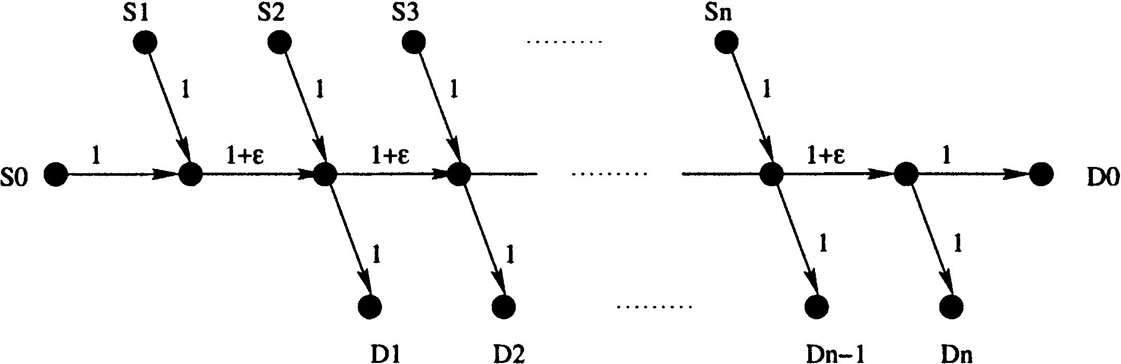
S. Suri et al. / Computer Communications 26 (2003) 351–365

Fig. 1. The parking-lot topology PL.

353

over a period of one hour, ﬂows with a total bandwidth of at
least 100 Mbps must be accepted. In Section 9, we describe
mechanisms to implement such policy constraints into our
framework.
Trafﬁc proﬁle. Our algorithm uses information about
‘expected’ ﬂows between some ingress – egress node pairs.
We explain the exact from of this information later, but
brieﬂy speaking our belief is that yesterday’s trafﬁc between
an ingress – egress pair can serve as a good predictor for
today’s trafﬁc. This should be especially true in light of the
fact that service providers aggregate a large number of
ﬂows, using forwarding equivalence classes, for the
ingress – egress pairs. Service providers can have multiple
classes per ingress – egress pair, and keep separate proﬁles
for various classes. These proﬁles can either be measure-
ment based or inferred from SLAs.
Routing information. Finally, like shortest-path routing,
our algorithm also uses only the link-state information and,
like the widest-path routing algorithm, it uses some
auxiliary capacity information. In order to keep the
presentation simple, we describe our algorithm for the
centralized route server model, although it can also be
implemented in a distributed fashion.

3. Review of existing algorithms

The most commonly used algorithm for routing LSPs is
the shortest-path routing, in which the least number of links
between ingress and egress nodes is chosen. Each of these
links has been assigned a cost or weight, to determine the
link’s preference. The routing algorithm keeps track of the
current residual capacity for each link, and only those links
that have sufﬁcient residual capacity for the new ﬂow are
considered. The shortest-path algorithm is very simple, but
it can also create bottlenecks for future ﬂows, and lead to
severe network underutilization (see examples in Section 5).
Our new algorithm is just as efﬁcient and fast as the shortest
path algorithm (during the path-selection phase), but by
using additional information about the network and trafﬁc in
a preprocessing phase the number of requests that might be
rejected because of inappropriate route selection can be
signiﬁcantly reduced. To reduce the creation of bottlenecks,
network operators often manually tweak the weights
associated with individual links heavily until the worst
bottlenecks have been resolved. Instead of full-ﬂedged

shortest path algorithm that has to deal with weights, our
algorithm could even use the simpler minimum-hop
algorithm (which is just a breadth-ﬁrst search) to select a
path in the online phase, thanks to the powerful
preprocessing.
Gueґrin et al. [11] propose a variant of the shortest-path
algorithm, called Widest – Shortest Path (WSP), in which
they choose a feasible shortest path that has the largest
residual capacity—in other words, the smallest link residual
capacity along the path is maximized. While WSP certainly
improves on shortest-path routing, it remains prone to
myopic behavior: it does not take into account the inﬂuences
that selecting a path between a given ingress – egress pair
has on a potentially large number of other pairs. WSP has no
notion of active ingress – egress pairs or trafﬁc character-
istics; all it cares for is the amount of bandwidth currently
available on the individual links and the requirements of the
ﬂow that is currently being routed. As it does neither know
nor care which other ingress – egress pairs will be impacted
and how much, WSP still can create bottlenecks as outlined
below. More signiﬁcantly, neither the shortest-path nor
WSP routing algorithm impose any form of admission
control. Thus, these algorithms will always accept a ﬂow if
there is a feasible path in the network, even if accepting that
ﬂow has the potential to block off a large number of future
ﬂows. Even when the path choice would perfectly minimize
the impact on other potential ﬂows, to give other ﬂows a
chance at all, it may sometimes be better to reject one ﬂow
in order to admit a large number of other ﬂows. The
example in Fig. 1 dramatically illustrates the effect of
admission control—without admission control, one can
force any online algorithm to achieve close to zero network
utilization!
The work most closely related to ours, and indeed the
basis for our work, is the MIRA of Kodialam and Lakshman
[2]. MIRA is a rather more sophisticated algorithm than
either shortest path or WSP, and it takes critical advantage
of ingress – egress pairs. The basic observation in Ref. [2] is
that routing a ﬂow along a path can reduce the maximum
permissible ﬂow between some other ingress – egress pairs.
Kodialam and Lakshman call this phenomenon ‘interfer-
ence’. Their thesis is that if paths that reduce a large amount
of possible maximum ﬂow between other ingress – egress
pairs are avoided, creation of bottlenecks can also be
avoided. Their algorithm performs multiple max-ﬂow
computations to determine the path of least interference.

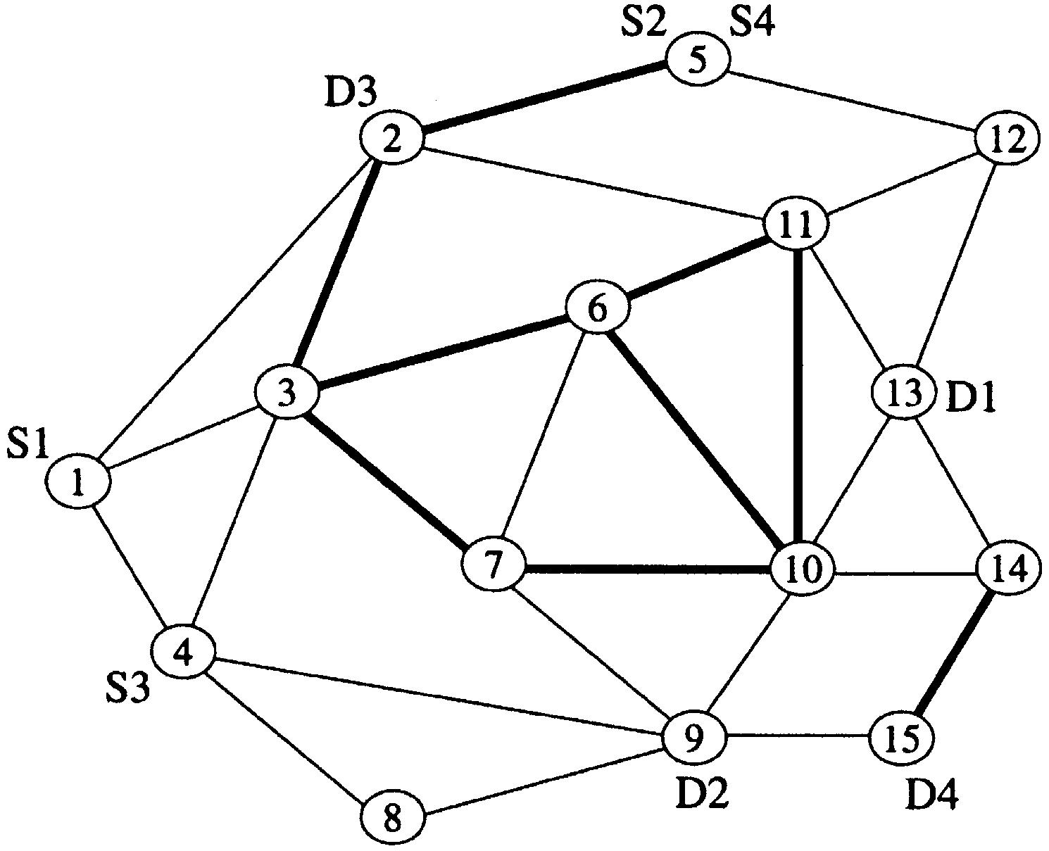
354

S. Suri et al. / Computer Communications 26 (2003) 351–365

subset of routers are assumed to be ingress – egress routers,
between which LSPs can be set up. We assume that the
ingress – egress pairs are known, and that this information is
quasi-static, i.e. that it changes very infrequently. An
example is shown in Fig. 2, which is borrowed from Kar –
Kodialam – Lakshman [14].¹We call this network the KL1
graph, and it is one of the several networks we used for our
simulations.
A request for an LSP setup is deﬁned by a quadruple (id;
s_{i}; d_{i}; b_{i}), where id is the request ID, s_{i}is the ingress (source)
router, d_{i}is the egress (destination) router, and b_{i}is the
bandwidth requested for the LSP. (The reason for having a
separate id for each request is that there can be multiple

Fig. 2. An example network, showing ingress – egress nodes.

Another approach to minimum interference routing is
presented in Ref. [12]. It deﬁnes interference based on the
notion of ‘critical paths’, which are computed using WSP. It
achieves the same performance as MIRA at a considerably
reduced computational complexity.
The idea of minimizing interference is a good one, but
we believe it has several limitations. First and foremost is
the observation that MIRA focuses exclusively on the
interference effect on single ingress – egress pairs. It is
incapable of estimating the bottleneck created on links that
are critical for clusters of nodes (see examples in Section 5).
Second, MIRA considers only the fact that using a given
link would reduce the maximum bandwidth between a pair,
without regard to the expected bandwidth between that pair.
Thus, MIRA might choose a wastefully long path, although
the more direct path retains sufﬁcient residual bandwidth to
accommodate the demands of other ﬂows. Third, MIRA has
no notion of admission control, which is necessary to
provide fairness and adhere to SLAs. Finally, MIRA is
computationally very expensive. While shortest-path, WSP,
and our new algorithm all perform a single shortest-path
computation to route a request, MIRA performs a maximum
ﬂow computation per ingress – egress pair, each of which
can be several orders of magnitude more expensive than the
shortest-path calculation.
Matta et al. [13] also use a proﬁle for making routing
decisions. For each source-destination pair, their proﬁle
contains a Probability Density Function (PDF) describing
the likelihood of individual request sizes. This PDF is then
used to reduce the link wastage among a set of alternate
routes. Load proﬁling is most effective when the request
sizes are large compared to the link bandwidth, and is
orthogonal to proﬁle-based routing.

4. Problem statement

We model the network as a graph G ј рV; EЮ; where V is
the set of routers and E is the set of links. The current
residual capacity of a link e [ E is denoted cap(e )—this is
the additional bandwidth that can be routed on link e. A
request for the same (s_{i}; d_{i}) pair). As mentioned earlier, all
QoS requirements for the ﬂow are assumed to have been
folded into the bandwidth b_{i}: Given a request (id; s_{i}; d_{i}; b_{i}),
the algorithm can either accept it, in which case it must ﬁnd
a path in the network from s_{i}to d_{i}along which each link has
a residual capacity of at least b_{i}or reject it. The admission
control feature allows our algorithm to reject a request even
if there is a feasible path—this may happen if the algorithm
determines that accepting this request creates a signiﬁcant
bottleneck for future requests (based on its knowledge of the
ingress – egress pairs and their trafﬁc proﬁle). We assume
that all LSP setup requests arrive online, one at a time, and
the algorithm does not know anything about individual
future requests, their bandwidth requirements, or their time
of arrival.
The trafﬁc proﬁle information used by our algorithm
records the expected ﬂow between pairs of ingress – egress
routers, and represents an aggregated demand proﬁle
between ingress – egress pairs. Such information can be
either measurement-based or calculated from SLAs that
have been entered by a service provider with its clients.
Each trafﬁc proﬁle is also deﬁned by a quadruple: (classID;
s_{i}; d_{i}; B_{i}), where classID is the trafﬁc class, s_{i}d_{i}are the
ingress and egress nodes, and B_{i}is the aggregate trafﬁc to be
expected for this class between s_{i}and d_{i}: Between the same
s_{i}; d_{i}pair, there can be multiple trafﬁc classes (correspond-
ing to different service types offered by the provider). Each
LSP request can be mapped to a unique trafﬁc proﬁle class.
(Conversely, a trafﬁc proﬁle class acts as an aggregate proxy
for all the LSP requests mapped to it.)
The trafﬁc proﬁle is rough indication of the amount of
trafﬁc that can be expected between a pair; however the LSP
setup request sequence arrives online. A convenient way to
think about this is that total sum of all LSP requests between
s_{i}and d_{i}for the class i is a random variable with mean B_{i}:
But the time of arrival of individual requests and their
bandwidth requirements are entirely unpredictable. Thus, as
far as our routing algorithm is concerned, the request
sequence is completely online.

1 This ﬁgure actually reﬂects the graph used for the MIRA measurements
in Ref. [14], although, according to one of the authors, the ﬁgure that was
printed in their paper does not correctly reﬂect all high-bandwidth links.

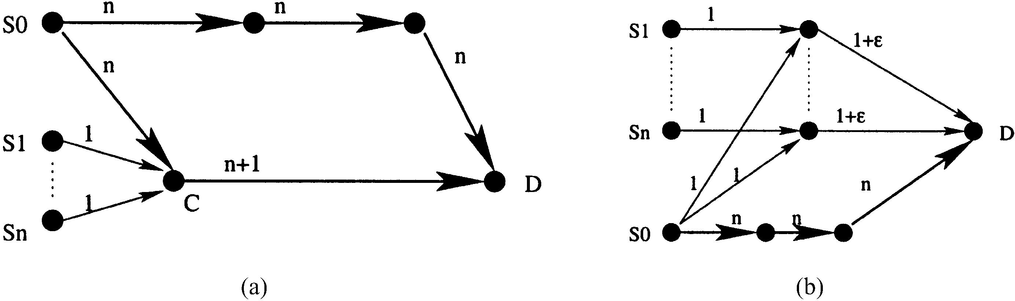
S. Suri et al. / Computer Communications 26 (2003) 351–365

Fig. 3. Example topologies. (a) The concentrator topology CN. (b) The distributor topology DS.

355

For simplicity, we assume there is a route server that
knows the current network topology and available link
capacities. Instead of dedicating a single machine to
perform route computations, this job could also be shared
among all ingress nodes without changes to the framework.

5. Examples illustrating limitations of existing routing
algorithms

In this section, we informally describe the shortcomings
of existing routing algorithms using some simple illustrative
examples. Our basic theme is that algorithms that do not
adapt to the trafﬁc distribution in the network (taking
advantage of ingress – egress pairs and some rough estimate
of the trafﬁc ﬂow between pairs) will always lead to
suboptimal network utilization, which can be quite severe in
some cases. In particular, the routing by algorithms such as
shortest-path and WSP that do not impose any form of
admission control can occasionally lead to signiﬁcant
bottlenecks. Simply having more information about the
network or trafﬁc does not guarantee better routing. Our
proposed framework assumes only a minimum of infor-
mation about the network and trafﬁc, which we believe can
be easily obtained. Our algorithm, although as simple and
computationally efﬁcient as the shortest-path algorithm,
leads to fewer rejected requests and better network
utilization.
We use three simple examples to illustrate the short-
comings of existing routing algorithms. In order to drive
home the point, these examples appear by necessity
artiﬁcial, but their general form is not at all unusual. In
fact, real networks are quite likely to contain subgraphs that
resemble the concentrator or the distributor example. The
parking-lot topology is common as well, but also depends
on the selection of ingress – egress pairs. As pair selection is
often outside the inﬂuence of the ISP, the occurrence of this
pathological case is likely to appear in the real world.
Parking Lot. Fig. 1 shows a simple network with 3n ю 3
nodes. The ingress – egress pairs for the LSP set up requests
are рS₀;^{D}0^{Ю}; рS₁;^{D}1^{Ю}; …; рS_{n}; D_{n}Ю; and the bandwidth
requested for each LSP is 1. All link capacities in the
network are either 1 or 1 ю 1, as shown.
Suppose the online sequence of LSP requests arrive in
the order рS₀; D₀Ю; рS₁;^{D}1^{Ю}; …; рS_{n}; D_{n}Ю: Accepting the

request рS₀; D₀Ю completely chokes off the network—no
other LSP request can be satisﬁed. However, as neither the
shortest path nor WSP will reject ﬂow requests if there is a
feasible path (independent of the resulting impact) they will
accept рS₀; D₀Ю; resulting in a total network utilization of 1.
An optimal algorithm will reject рS₀; D₀Ю; and accept
рS₁;^{D}1^{Ю}; …; рS_{n}; D_{n}Ю; for a total network utilization of n.
The choice of capacity 1 ю 1 for the links along the spine
of the parking-lot also foils MIRA—as these links are not in
the min cut for any рS_{i}; D_{i}Ю pair, and are not considered
critical. Even if MIRA were modiﬁed to support admission
control, it would still accept the ﬁrst ﬂow request and end up
rejecting all other requests.
Although the links are drawn as directed, path selection
and blocking behavior would remain the same for bi-
directional links. In the following two examples, some of
the links need to be unidirectional. Even though uni-
directional links are rare (i.e. satellite downlinks and
downstream-only cable modem installations), uni-
directional remaining capacity is quite common. Because
of asymmetric links or loads, the remaining capacity in the
opposite direction could become too small to be useful.
Concentrator. Fig. 3(a) shows a network, which we call a
concentrator graph—one node C acts a feeder for n ingress
nodes S₁; …; S_{n}: The concentrator node C is connected to a
high-capacity link, fat pipe, of capacity n ю 1,whose other
endpoint is egress node D. One high-bandwidth ingress S₀is
also connected to the concentrator, though a capacity-n link.
S₀is also connected to D via an alternative three-hop path of
capacity n.
In this example, an online sequence of n ю 1 requests
arrive: рS₀; DЮ; рS₁;DЮ; …; рS_{n}; DЮ: The ﬁrst request has
bandwidth requirement n, all others have bandwidth
requirement 1. Using either the shortest path or the WSP,
one would route the ﬁrst request through the concentrator
node (using two hops). This leaves residual capacity 1 along
the link CD, and thus at most one of the remaining n
requests can be satisﬁed.
This example also illustrates the shortcoming of
MIRA—the fat link CD is not in the minimum cut for any
individual ingress – egress pair. Thus saturating it does not
seem harmful to MIRA, and accordingly MIRA will also
choose incorrect paths in this scenario. The optimal
algorithm will route the рS₀; DЮ request along the top

356

S. Suri et al. / Computer Communications 26 (2003) 351–365

alternative path, and use the fat link to route the n 1-unit
requests from S_{i}to D.
Distributor. While the preceding example shows why it
sometimes may be a good idea not to use the fat pipe, our
next example shows that the converse is also true.
In the example shown in Fig. 3(b), we get n requests
between S₀and D, each of bandwidth 1. In addition, we also
get n requests between each S_{i}and D, also of bandwidth 1.
Again, the shortest-path algorithms (shortest path and WSP)
will use the two-hop paths for each of the ﬁrst n requests,
choking off the 1 ю 1 links. Thus, each of the remaining n
requests between S_{i}and D is rejected. The routes selected by
MIRA are also the same, as the links of capacity 1 ю 1 are
not in the minimum cut for any S_{i}, D pair. By contrast, the
optimal algorithm will route all the requests from S₀along
the bottom fat path (three hops), leaving the top two-hop
paths for S_{i}to D requests.
The preceding examples are intended to illustrate how a
bad path selection for one ﬂow can create signiﬁcant
bottlenecks for future ﬂows. An online routing algorithm
that has no additional information about the ﬂows can
perform quite poorly in the worst case. As the parking-lot
example shows, in some cases these algorithms cannot
guarantee that even 1% of the network bandwidth is utilized,
whereas the optimal algorithm achieves 100%. We build on
the work by Kodialam and Lakshman [2], and propose a
new algorithm as well as a general framework, in which we
exploit information about the ingress – egress nodes as well
as measured (or estimated) trafﬁc proﬁle to perform both
path selection and admission control. Our algorithm is both
simpler than MIRA, and it also performs better in many
cases where MIRA falls into the same traps as the shortest
path or widest shortest-path routing algorithms.²

6. Multi-commodity ﬂows

We begin with the observation that even if the exact
sequence of tunnel requests were known in advance, the
problem is intractable. In particular, given an ofﬂine
sequence of LSP setup requests, it is NP-Complete to
determine the maximum number of requests that can be
simultaneously routed. Thus, the difﬁculty lies not necess-
arily in the online nature of the problem, but rather in having
to choose which of many paths to select for routing a ﬂow.
We turn this difﬁculty around by formulating the ofﬂine
problem as a multi-commodity ﬂow problem, on a modiﬁed
network. We use the trafﬁc proﬁle data for the ingress –
egress pairs as the ofﬂine aggregate data. The solution to the
multi-commodity ﬂow problem is then used to preallocate

2 Although MIRA later received a sibling, L-MIRA [14], which adds a
fuzz factor when determining the bottleneck links, this is easily defeated
either artiﬁcially by appropriately choosing 1 or naturally through the
inherent dynamic nature of the allocation process. In the latter case, adding
ﬂows to the ‘better’ link will soon shrink its available bandwidth, getting it
beyond the fuzz threshold.

link capacities to various ﬂows, which are then used by the
online algorithm to perform path selection. When the
allocated capacity for a ﬂow becomes zero (or was initially
assigned zero), that ﬂow request is rejected—even though
there might be sufﬁcient capacity in the network to route it.
Let us begin with some preliminaries about multi-commod-
ity ﬂows. Interested readers can ﬁnd a comprehensive
treatment of network ﬂows in Ref. [15].
Given a directed Graph G ј рV ; EЮ; with positive
capacity cap (u; v) for each edge (u; v), a ﬂow on G is a
real-valued function f on node pairs having the following
properties:
Skew Symmetry. f рv; wЮ ј 2f рw; vЮ: If f рv; wЮ . 0; then
there is a ﬂow from v to w.
Capacity Constraint. f рv; wЮ # capрv; wЮ: If рv; wЮ is not
an edge of G, then we assume that capрv; wЮ ј 0:
Flow Conservation. For every vertex v, other than the
source or the sink (i.e. ingress or egress), the ﬂow is
conserved:^{P}w^{f}рv; wЮ ј 0:
It is straightforward to prove that the problem of
determining whether a given (ofﬂine) set of LSP requests
can be routed is NP-Complete.

Theorem 1. Given a network G ј рV; EЮ; where each link
has a positive capacity, and a set of k LSP requests
рid; s_{i}; d_{i}; b_{i}Ю; for i ј 1; 2; …; k; deciding whether it is
possible to simultaneously route all k requests in G is
NP-Complete.

Indeed, the LSP routing problem is a generalization of
the simple two-commodity integral ﬂow problem, which is
known to be NP-Complete [16]. The two-commodity
integral ﬂow problem asks whether it is possible to ﬁnd
two ﬂow functions that deliver some required set of ﬂows
from two source nodes to two sink nodes. Speciﬁcally,
suppose we are given a directed graph G ј рV; EЮ; node
pairs рs₁; d₁Ю; рs₂; d₂Ю; positive integral capacity capрeЮ for
each edge e [ E; and bandwidth requirements b₁and b₂:
Then, it is NP-Complete to decide whether there are ﬂow
functions f₁; f₂such that (1) for each link e [ E; f₁рeЮ ю
f₂рeЮ # capрeЮ; (2) for each node other than s₁; s₂; d₁; d₂;
ﬂows f₁and f₂are conserved, and (3) the net ﬂow to d_{i}under
f_{i}is at least b_{i}:
We are now ready to describe the details of our
algorithm.

7. Proﬁle-based routing

Examining the problem more closely, we ﬁnd that the
intractability of the LSP setup problem stems from two
requirements: unsplittability of the ﬂows, and separate
demand functions for each ﬂow. In other words, if ﬂows are
allowed to be split, and if the objective is to maximize total
ﬂow rather than to satisfy each individual ﬂow, then the
problem can be solved efﬁciently through linear

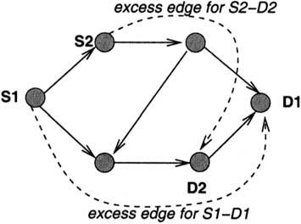
S. Suri et al. / Computer Communications 26 (2003) 351–365

357

Fig. 4. The excess edges added to make the multi-commodity ﬂow always
feasible.

excess edge between each ingress – egress pair, shown as
dashed lines in Fig. 4. Thus, costрeЮ ј 1 if e [ E, and
costрeЮ ј capрeЮ ј 1 if e is an excess edge, where 1 is an
appropriately large number. The large cost of the excess
edges forces as much of the feasible ﬂow as possible to go
through original network edges. Let G⁰denote the graph
obtained by adding these excess edges.
Now, let x_{i}рeЮ denote a real-valued variable, denoting the
amount of commodity i that is routed through edge e. Then,
the multi-commodity problem to be solved for graph G⁰is to

programming. Unfortunately, in the LSP problem, we do not
want ﬂows to be split, and we do want to enforce some kind

minimize
X X
costрeЮ
iј1
!
x_{i}рeЮ

of fairness to admit as many ﬂows as possible. Fortunately,
we are able to ﬁnesse the problem on both counts by using a
multi-commodity ﬂow framework on the trafﬁc proﬁles,
rather than individual ﬂows. First, the individual ﬂow
request sizes are typically much smaller than the link
capacities—for instance; the link capacities might range
from OC-12 to OC-192, while a typical request might be
just a few megabits per second. Second, we use the multi-
commodity ﬂow in the preprocessing phase, where
‘commodities’ correspond to highly aggregated trafﬁc
proﬁles, rather than to individual LSP requests. So, when
a commodity is split, it does not mean that a ﬂow is split; it
merely means that a ‘group’ of ﬂows is routed on a different
path than another group. An individual LSP request is never
split—our algorithm either ﬁnds a single path to route it, or
rejects it.
Our algorithm has two phases: a preprocessing phase, in
which we solve a multi-commodity ﬂow problem to pre-
allocate link capacities for various trafﬁc classes, and an
online routing phase, in which LSP request is routed online
using a shortest-path-like algorithm. Let us ﬁrst describe the
preprocessing phase.

7.1. Multi-commodity ﬂow preprocessing

The input to the preprocessing phase is the network
G ј рV ; EЮ; with capacity cap(e ) for each edge e [ E.
We are given a set of trafﬁc proﬁles (classID; s_{i}; d_{i}; B_{i}Ю;
where classID is the trafﬁc class, s_{i}; d_{i}are the ingress
and egress nodes, and B_{i}is the aggregate bandwidth
requirement for this class between s_{i}and d_{i}: We treat
each trafﬁc class as a separate commodity. Suppose
there are k commodities, numbered 1 through k. The
goal is to ﬁnd routes in the network to send as much of
each commodity as possible from its source node to the
destination node.
However, as noted earlier, satisfying all bandwidth
requirements may not be possible. We therefore put
additional edges in the network, called excess edges, so
that the problem always has a feasible solution, and use edge
costs to distinguish between the network edges and the
excess edges. In particular, we add an inﬁnite capacity
subject to the following constraints:

† capacity constraints are satisﬁed for all edges—if e is not
an excess edge, then^{P}k_{i}ј1^{x}i^{р}eЮ # capрeЮ;
† the ﬂow for each commodity is conserved at all nodes,
except at the corresponding ingress and egress nodes, and
† the amount of commodity i reaching its destination, d_{i}; is
B_{i}:

The output of the multi-commodity ﬂow computation is
the values for the variables x_{i}рeЮ: We use these values to set
a pre-allocation of the capacity of the edges e for various
ﬂows. In other words, the x_{i}рeЮ part of e’s capacity will be
used by the online algorithm to route ﬂows belonging to
trafﬁc class (and thus ingress – egress pair) i. In summary,
the multi-commodity phase of the algorithm determines
admission control thresholds for each trafﬁc class, and
computes pre-allocation of link capacities to maximize
network utilization. The online routing phase of the
algorithm is described next.

7.2. Online path selection for LSP requests

The input to this phase of the algorithm is the input graph
G ј рV; EЮ; where for each edge e [ E; we keep track of
the residual capacity r_{j}рeЮ for each trafﬁc class j ј
1; 2; …; k: (Note that these residual capacities are per trafﬁc
class, not per ﬂow.) The initial value for r_{j}рeЮ is set to x_{j}рeЮ;
which is the output of the multi-commodity preprocessing
phase. The algorithm then processes an online sequence of
LSP setup requests (id; s_{i}; d_{i}; b_{i}Ю; where id is the request ID,
s_{i}is the ingress (source) router, d_{i}is the egress (destination)
router, and b_{i}s the bandwidth requested for the LSP. We
assume that each LSP can be mapped (by the ingress router
s_{i}) to a unique trafﬁc class. Our online routing algorithm
runs on the reduced graph, which uses the pre-allocated
capacities corresponding to this class. In this reduced graph,
we select a minimum-hop path between s_{i}and d_{i}; if one
exists.
To allow for signiﬁcant deviations from the proﬁle, the
network operators may choose to hide some percentage of
the link bandwidths from the multi-commodity ﬂow

358

S. Suri et al. / Computer Communications 26 (2003) 351–365

computation and make it available only at the time of ﬂow
routing on a ﬁrst-come ﬁrst-serve basis. The classless
residue available this way on link e is referred to as R(e ).³

Algorithm 1. Input. The input graph G ј рV ; EЮ: For each
edge e, we maintain residual capacity r_{j}рeЮ for each
commodity (trafﬁc class, i.e. ingress – egress pair) j ј
1; 2; …; k: In addition, each edge maintains a classless
residue, R(e ), which can be used by all commodities, once
their capacities are exhausted. For standard proﬁle-based
routing, all R(e ) can be considered zero. The LSP request is
between an ingress – egress pair s; d; and the bandwidth
requirement is b. Let j be the trafﬁc class to which this LSP
belongs.
Output. A path from s to d, such that for each edge e along
this path there had been r_{j}рeЮ $ b (during the algorithm
r_{j}рeЮ—and possibly R(e )—are updated to contain the new
residual bandwidths).
Operation:

(1) Delete from G all edges e for which r_{j}рeЮ ю RрeЮ , b:
(These edges have insufﬁcient residual capacity for
class j.)
(2) In the reduced graph, ﬁnd a path P with minimum
number of hops, using a breadth ﬁrst search, from s to
d.
(3) For each edge e in path P, decrease the residual
capacity r_{j}(e ) by b. If the resulting r_{j}(e ) becomes
negative, bandwidth is taken from R(e ) as required.
(4) Route LSP (s, d, b ) along path P.

7.3. Complexity analysis

If the network has N nodes and M edges, the breadth ﬁrst
search algorithm computes a shortest path in OрN ю MЮ
time. This is a linear-time algorithm, and should be several
orders of magnitude faster than the MIRA algorithm, which
needs to perform several (as many as the number of
ingress – egress pairs) maxﬂow computations. Each of these

require recomputation unless the network information
changes, such as ingress – egress pairs or their trafﬁc proﬁle.
Those changes are very infrequent. Thus, our algorithm
needs occasional heavy preprocessing to build a pre-
allocation table, which it then uses to run the online path-
selection phase.

7.4. Network dynamics

So far, we considered the network topology and proﬁle to
be static. In this section, we will discuss the results of link
failures/additions or proﬁle changes. As the problem
becomes trivial when rerouting of existing ﬂows is possible,
we will only discuss the cases when rerouting is not an
option.
When a link is removed, the following steps can be taken
to get the network back into operation. It is assumed that the
ﬂows that have been severed by the link failure should be
restored on the new topology.

(1) Remove the link from the graph.
(2) Remove all ﬂows that crossed the link and remember
them.
(3) Create a graph of a residual network, in which the
capacity of each link is described by the total residual
capacity рRрeЮ ю^{P}r_{j}рeЮЮ of that link in the real
network.
(4) Create a residual proﬁle, which is the base proﬁle
reduced by the capacities of the currently routed ﬂows.
(5) Run the multi-commodity ﬂow computation with the
residual network and proﬁle (same complexity as
initial computation, Section 7.3).
(6) Try to reroute the ﬂows that crossed the removed
link.

When a new link is added, the multi-commodity ﬂow
computation is also run using residual networks and proﬁles
similarly created. A reduction or increase of the capacity of
a link is handled as a straightforward modiﬁcation of the
link removal or addition process, respectively.

maxﬂow computation itself takes OрN²ﬃﬃﬃ_{Ю}time. Addition-
ally, MIRA needs to enumerate the links belonging to
minimum cuts, which is of complexity OрM²Ю: Thus, the
total complexity of MIRA is OрN²pﬃﬃﬃ_{ю}M²Ю: During the
path-selection phase, our algorithm has the same run-time
complexity as the currently used shortest-path algorithm.
Our algorithm is faster than the WSP routing algorithm,
because that algorithm must execute a Dijkstra-style
shortest-path computation [17].
The preprocessing phase of our algorithm solves a
minimum cost multi-commodity ﬂow problem, which can
be slow. But that step can be executed ofﬂine, and does not

3 To avoid unnecessary fragmentation when a classless residue is desired
for additional ﬂexibility, R(e ) should either be taken away before running
the multi-commodity ﬂow algorithm or taken away as a ‘tax’ from all paths.
7.5. Dynamic proﬁles

When a proﬁle is changed at run time and rerouting of
existing ﬂows is not an option, the changes may be activated
as described in Section 7.4, using residual networks and
proﬁles.
When no a priori proﬁle information is available, but it
can be assumed that current demand is an indication of
future demand, self-proﬁling can be used: after routing the
ﬁrst few requests without a proﬁle, using a standard routing
algorithm, a proﬁle is extrapolated from the requests seen so
far. This proﬁle is then used to route future requests, again
using residual networks and proﬁles. Self-proﬁling is also
useful if the actual network trafﬁc is expected to deviate
signiﬁcantly from the recorded proﬁle.

Table 1
Worst-case performance improvement

S. Suri et al. / Computer Communications 26 (2003) 351–365

359

Graph name
Total requests
Requests routed by
Factor of improvement

PL
CN
DS

1 ю n
2n
2n

SP

1
n
n

WSP

1
n
n

SWP

1
n
2n 2 1

MIRA

1
n
n

PBR

n
2n
2n

n
2
2 (except SWP)

8. Performance results

Without real network topologies and large amounts of
trafﬁc data, it is difﬁcult to perform meaningful and
conclusive experiments. We will follow the tradition set
by other authors, and perform experiments on several
handcrafted topologies, using both worst-case and synthetic
ﬂow data. We present qualitative as well as quantitative
evidence for why we believe our Proﬁle-Based Routing
(PBR) algorithm should (and does) perform better than
others. One highly attractive feature of our algorithm is that
computationally it is online as efﬁcient as the shortest-path
or WSP routing, and substantially faster than MIRA.
In this section, we compare the performance of PBR with
the well-known path computation algorithms Shortest-Path
(SP), Shortest – Widest-Path (SWP), and WSP. In addition,
we also include performance ﬁgures of a MIRA based on
ﬂow maximization. This algorithm uses an approximation
for maximizing the weighted sum of ﬂows among ingress –
egress pairs, which is described in more detail in Ref. [18].
We denote this algorithm WSUM-MAX Approximation (or
WSUM-MAX for short), which, similar to MIRA, tries to
approximate the WSUM-MAX problem [14]. This approxi-
mation should meet or exceed a performance comparable to
MIRA, especially as it avoids some of the pitfalls described
earlier for MIRA.⁴
We used four network topologies to measure the
performance of our PBR algorithm. The ﬁrst three
topologies are the ones we used in Section 5. The fourth
topology, referred to as KL1, is the one used by Kodialam
and Lakshman [2] in their experiments. It will be used with
different ingress – egress pairs and link weights, as explained
in the simulation section.
In the Parking-Lot Topology (PL), all link capacities are
set to 4800 (to model OC-48). In the Concentrator (CN) and
Distributor (DS) topologies, we used n ј 5; and scaled up
all link capacities by 800. Thus, all links with capacity 1 in
Fig. 3(a) and capacity 1 ю [ in Fig. 3(b) become links of
capacity 800, while those with capacity n or n ю 1 become
links of capacity 4800. In the KL1 network, all light edges
have capacity 1200, while dark ones have capacity 4800
(meant to model OC-12 and OC-48 links, respectively),
matching the values used in Ref. [14]. Finally, we used a

4 We had to revert to using this algorithm as an approximation of MIRA,
as the MIRA speciﬁcation is not sufﬁciently complete to create an
independent implementation suitable for direct performance comparison.

publicly available implementation of the minimum cost
multi-commodity ﬂow algorithm, the PPRN package, for
our preprocessing phase (available at http://www-eio.upc.
es/~jcastro/pprn.html).
The experiments have been conducted in a route server
environment as described in Ref. [19]. In each experiment,
we generated a random sequence of individual requests, and
measured the performance of the various path computation
algorithms. All of the experiments are conducted using
‘static’ requests, which means that the bandwidth allocated
for a request is never freed again. The results shown are
average values of 20 test runs for each experiment, except
experiment 5, which shows average values of 100 test runs.

8.1. Worst-case analysis

In this ﬁrst comparison, we revisit the three topologies
(PL, CN, and DS) from Section 5 and infer the worst-case
behavior of shortest-path, WSP, MIRA, and PBR on these
topologies without simulation. Table 1 documents these
results.
In the PL topology, if the ﬁrst request is between nodes S₀
an D₀, then all greedy algorithms (shortest path, WSP, SWP,
and MIRA) accept it, which blocks all future requests from
being routed. As the number of ingress – egress pairs n
increases, the percentage of network utilized by the greedy
algorithms goes to zero. In order to avoid such a near-zero
utilization of the network, our new algorithm (PBR) rejects
the ﬁrst request, and is then able to satisfy all remaining n
requests between S_{i}and D_{i}.
Even if MIRA were extended by a cost threshold (total
weight , W ) for admission control, it would not work for this
topology because none of the edges used by the ﬁrst path from
S₀to D₀are in the minimum cut of any (S_{i}, D_{i}) pair, and
consequently the weights of these edges remain zero.
In the CN topology, a single request of size n by source
S₀will be routed by both shortest path and MIRA along the
path that goes through the concentrator node C, which then
blocks all future requests between S_{i}and D. In this case, the
edge CD is not found to be critical by MIRA because it does
not belong to the minimum cut of any single ingress – egress
pair; it is only in the minimum cut for a cluster of ingress –
egress pairs. Thus, in this case, PBR routes all 2n units of
trafﬁc, while the other three algorithm route only n units.
The same performance is also observed in the DS
topology, except that shortest – widest path routing (SWP)

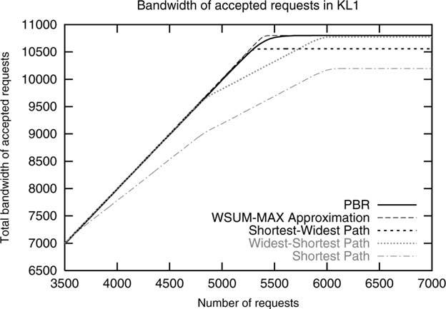
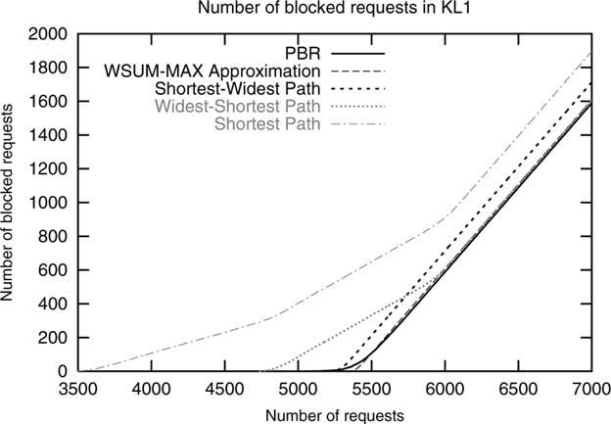
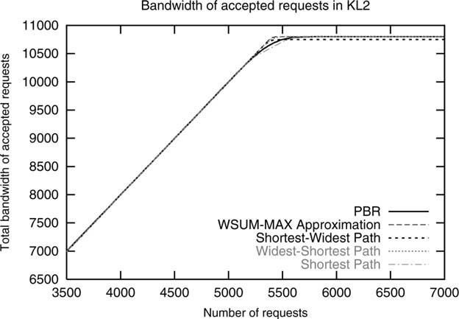
360

S. Suri et al. / Computer Communications 26 (2003) 351–365

Fig. 5. Throughput of accepted requests using demands of 1 – 3 in KL1.

will choose the correct path for the ﬁrst n 2 1 ﬂows of unit
size from S₀to D.

8.2. Experiment 1: uniform link costs

Experiment 1 has been conducted on KL1 network
shown in Fig. 2. The network has been loaded with 7000
requests, having bandwidth demands uniformly distributed
in the range of 1 – 3 units (only integer values are used).
Also, the requests have been uniformly distributed among
the ingress-egress pairs. Consequently, WSUM-MAX has
been conﬁgured to use equal weights for the ingress – egress
pairs and the trafﬁc proﬁle for PBR has been computed
using the multi-commodity ﬂow algorithm with ‘inﬁnite’
supply for each ingress node. This computation resulted in
ﬂows of 2700 units of bandwidth between each ingress –
egress pair. The link ‘costs’ are set to 1, such that the
shortest-path algorithm is reduced to a minimum-hop
algorithm.
The bandwidth of accepted requests of experiment 1 is
shown in Fig. 5. For each of the algorithms, the bandwidth
increases with the number of requests until a saturation
point is reached at which no more requests can be
accommodated, and the network is saturated. The ﬁrst
performance measure we use is the bandwidth of success-

Fig. 6. Blocked requests using demands of 1 – 3 in KL1.

Fig. 7. Throughput of accepted requests using demands of 1 – 3 in KL2.
fully routed requests after the saturation point has been
reached. The SP shows the weakest performance, with a
saturation point around 10,200 bandwidth units. The best
performance is shown by PBR and WSUM-MAX with
10,800 units, followed very closely by WSP with 10,770
units, and SWP with 10,550 units. Note that because of the
random process that is used to generate the requests, PBR
reaches its saturation point slightly later than WSUM-MAX,
after having routed exactly 2700 units of bandwidth
between each ingress – egress pair. WSUM-MAX, on the
other hand, is more ﬂexible in the sense that it allocates the
bandwidth on a ﬁrst-come ﬁrst-serve basis. Similar to
the cases discussed for MIRA, this makes WSUM-MAX
susceptible to creating bottlenecks.
A second performance measure looks at the number of
blocked requests. Fig. 6 shows the number of blocked versus
total requests. While SP starts to block requests after 3500
requests, PBR and WSUM-MAX start to block requests
only after 5125 and 5340 requests, respectively.
In this and all other experiments with small request sizes,
20 test runs were carried out, and the results shown are the
mean values obtained. The experiments have a 99.9%
conﬁdence interval of not exceeding 1% of the mean values.
(For experiment 5, which uses much larger request sizes, the
resulting spread is presented together with the other data.)

8.3. Experiment 2: link costs inversely proportional to link
capacity

In the next experiment, we study the effect of static link
costs on the performance. In network KL1, all links have a
cost of 1. We obtain network KL2 by assigning different
costs to the links. Following a common practice, we assign
link costs inversely proportional to the link capacities. Links
with capacity 1200 are assigned a cost of 4, and links of
capacity 4800 are assigned a cost of 1. This results in
network KL2. The remaining parameters are unchanged.
Please note that path selection done by PBR (as well as
WSUM-MAX and MIRA) is independent of the link costs,

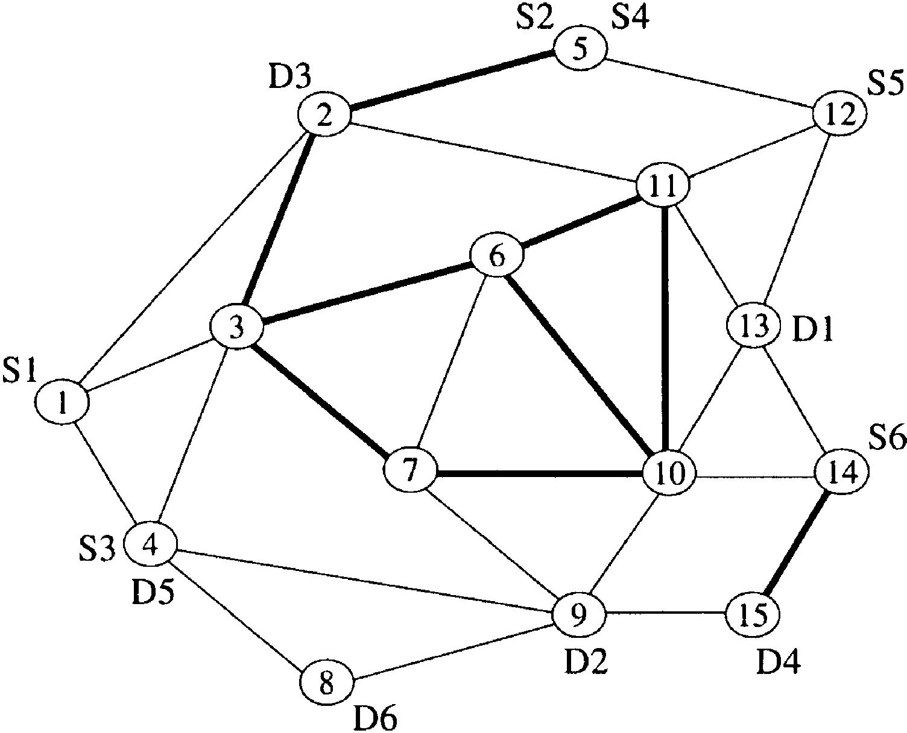
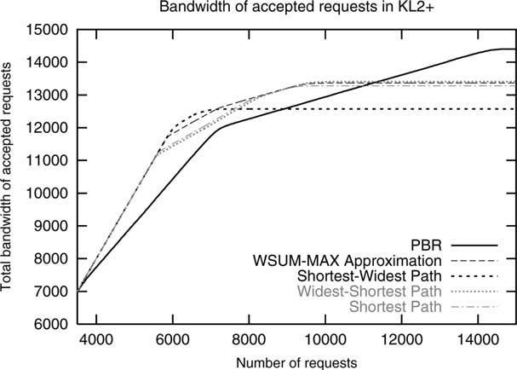
S. Suri et al. / Computer Communications 26 (2003) 351–365

Fig. 8. Example network KL2 ю with additional ingress – egress pairs.

361

and thus their performance remains unchanged to the
previous experiment.
Fig. 7 shows the bandwidth of accepted requests in
network KL2. Thanks to setting the link costs favorably for
the link-cost-based algorithms (SP, SWP, WSP) and the
generally low interference in this graph, even the less
sophisticated algorithms perform very well. Except for
SWP, all algorithms eventually achieve the theoretical
maximum of 10,800 units. However, SP and also PBR
achieve this maximum slightly later than the other
algorithms. PBR’s slight delay is due to its use of admission
control, which would not really be necessary in this graph
which is well tuned to the offered load, but is very helpful
when the routing behavior should be predictable or is
subject to side constraints such as SLAs.

8.4. Experiment 3: additional ingress – egress pairs

In a third experiment, we increase the number of
ingress – egress pairs and therefore interference. Fig. 8
shows the example network after two additional ingress –
egress pairs have been added to KL2. We refer to this
network as KL2 ю . Note that, unlike the corresponding
MIRA topology from Ref. [14], the link costs are again
inversely proportional to the link capacities, to reﬂect
common practice and aid the cost-based algorithms (SP,
SWP, WSP).
For the third experiment, 15,000 requests have been
issued for network KL2 ю . As in the previous experiments,
the requests are uniformly distributed among the six
ingress – egress pairs and the bandwidth demand is an
integer value uniformly distributed in the range from 1 to 3.
WSUM-MAX uses equal weights for the ingress – egress
pairs. For PBR, the proﬁle has been computed using the

Table 2
Proﬁle generated for KL2 ю
Fig. 9. Throughput of accepted requests using demands of 1 – 3 in KL2 ю
and a PBR proﬁle that maximizes the total throughput.
multi-commodity ﬂow algorithm, resulting in a ﬂow
distribution as shown Table 2.
Fig. 9 shows the bandwidth of accepted requests in
KL2 ю . The largest total throughput is achieved by PBR.
At the same time, PBR starts blocking requests for pairs
S1 ! D1 and S6 ! D6 the earliest. The reason for this
behavior is the fact that requests for all ingress – egress pairs
are uniformly distributed, whereas the calculated maximum
proﬁle differs up to a factor of 4. Nevertheless, PBR
achieves a total throughput of 14,400 units, whereas, WSP,
WSUM-MAX and SP only achieve 13,400, 13,360, and
13,380, respectively.
In order to have PBR achieve a uniform distribution
among the ingress – egress pairs, we compute a PBR proﬁle
by solving the multi-commodity ﬂow problem with a supply
of 2400 units for each of the six pairs. In the resulting
proﬁle, each pair supports 2400 units of bandwidth except
pair S2 ! D2, which is only able to carry 1200 units of
bandwidth. The resulting aggregated throughput is shown in
Fig. 10.

8.5. Experiment 4: weighted request distribution

The fourth experiment has been carried out on network
KL2 ю . Unlike in the previous experiments, the requests
were not uniformly distributed, but followed the distribution
given in Table 3. The relative weights used for WSUM-
MAX, which match the proﬁle shown in Table 2, are shown
in the second row of Table 3. PBR has been used with the
proﬁle given in Table 2.
The results of this experiment are shown in Fig. 11. As
expected, PBR achieves the maximum theoretical through-
put of 14,400 units of bandwidth. WSUM-MAX follows

Flow value
S1 ! D1

1200
S2 ! D2

2400
S3 ! D3

4800
S4 ! D4

2400
S5 ! D5

2400
S6 ! D6

1200

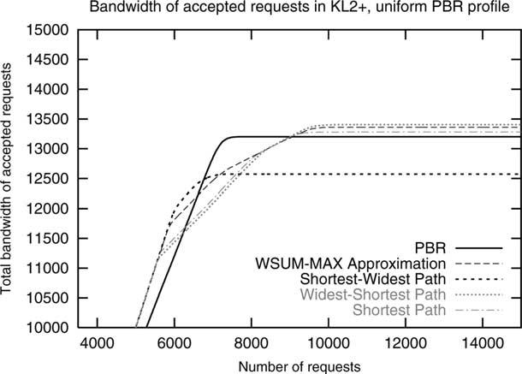
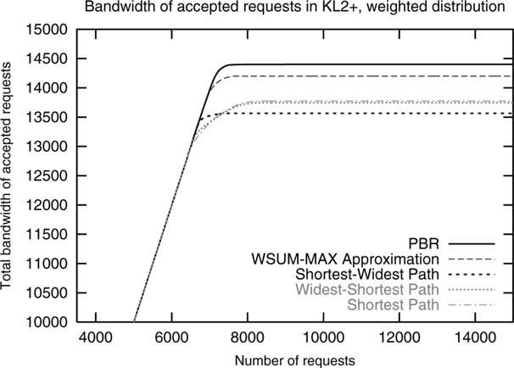
362

S. Suri et al. / Computer Communications 26 (2003) 351–365

Fig. 10. Throughput of accepted requests using demands of 1 – 3 in KL2 ю
and a uniform PBR proﬁle (bandwidth artiﬁcially limited to 13,200 units).
closely behind with a total throughput of 14,200 units of
bandwidth. WSP and SP both achieve 13,750 units of
bandwidth, whereas SWP only achieves slightly more than
13,500.

8.6. Experiment 5: large demands

The last experiment is a repetition of experiment 4 but
using different demand sizes. The demand sizes have been
scaled by a factor of 100 and thus cover 100 – 300 units of
bandwidth (again only integer bandwidths are chosen from
the range). The proﬁle used for PBR and the relative weights
used for WSUM-MAX remain unchanged. Fig. 12 shows
the average values of 100 test runs. While the ranking of the
algorithms remains the same, the performance difference
increase. This is due to the fact that an increased request size
also increases a ﬂow’s blocking effect through fragmenta-
tion of the remaining bandwidth.
For experiment 5, 100 test runs have been carried out,
using a random process for selecting the ingress – egress
pairs and the demand sizes. Thus, each test run used its own
pattern of requests and demand sizes. Fig. 13 shows the
variation of the total routed bandwidth and the number of
blocked requests for the different algorithms after 60 and
100 requests have been issued, respectively. After 60
requests, all of the algorithms show the same behavior. At
this point, some of the requests are being blocked, but the
network is already saturated to a large degree. In this
situation, PBR clearly exhibits the smallest variation
regarding the amount of accepted bandwidth. This means
that PBR’s performance is largely independent of the
request pattern used. This is in contrast to the other

Table 3
Distribution of requests for experiment 4

Fig. 11. Throughput of accepted requests using a weighted distribution of
demands of 1 – 3 in KL2 ю .
algorithms, in which the variation in total routed bandwidth
is more than twice that of PBR. Additionally, the number of
blocked requests is considerably lower in PBR than in any
of the other algorithms.

8.7. Analysis of the simulation results

All algorithms (with the exception of WSP and some-
times SP) generally perform very well when the per-link
costs have been carefully assigned and interference is low.
While careful tuning of link loads is currently the norm
among ISPs, this cumbersome process which has to be
repeated whenever a link fails or is added can be eliminated
by PBR.
For high interference and asymmetric load, PBR is able
to sustain a (potentially much) higher load. We expect these
networks to be the norm, especially for large ISPs. Doing
the access control necessary to achieve such high loads,
PBR may block a few requests violating the proﬁle to ensure
that it can admit more bandwidth from conforming ingress –
egress pairs later.
We do not expect this blocking to have much impact in
real-world networks. First, we expect proﬁles to be a
meaningful prediction of the short-term future; those
customers with large bandwidth demands will typically
show some long-term stability. Second, the multi-com-
modity ﬂow preprocessing is able to preallocate at least as
much bandwidth as the other algorithms (this is true for
all simulations, except where the multi-commodity ﬂow
algorithm has been forced not to use all bandwidth). The
actual ﬂows to be admitted thus gain signiﬁcant
headroom.

Distribution
Weights
S1 ! D1

1/12
0.5
S2 ! D2

1/6
1
S3 ! D3

1/3
2
S4 ! D4

1/6
1
S5 ! D5

1/6
1
S6 ! D6

1/12
0.5

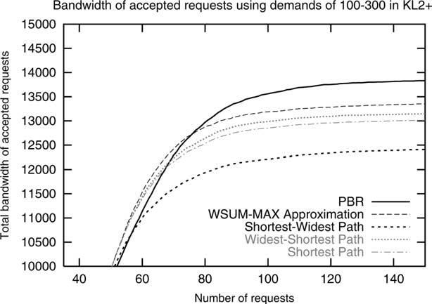
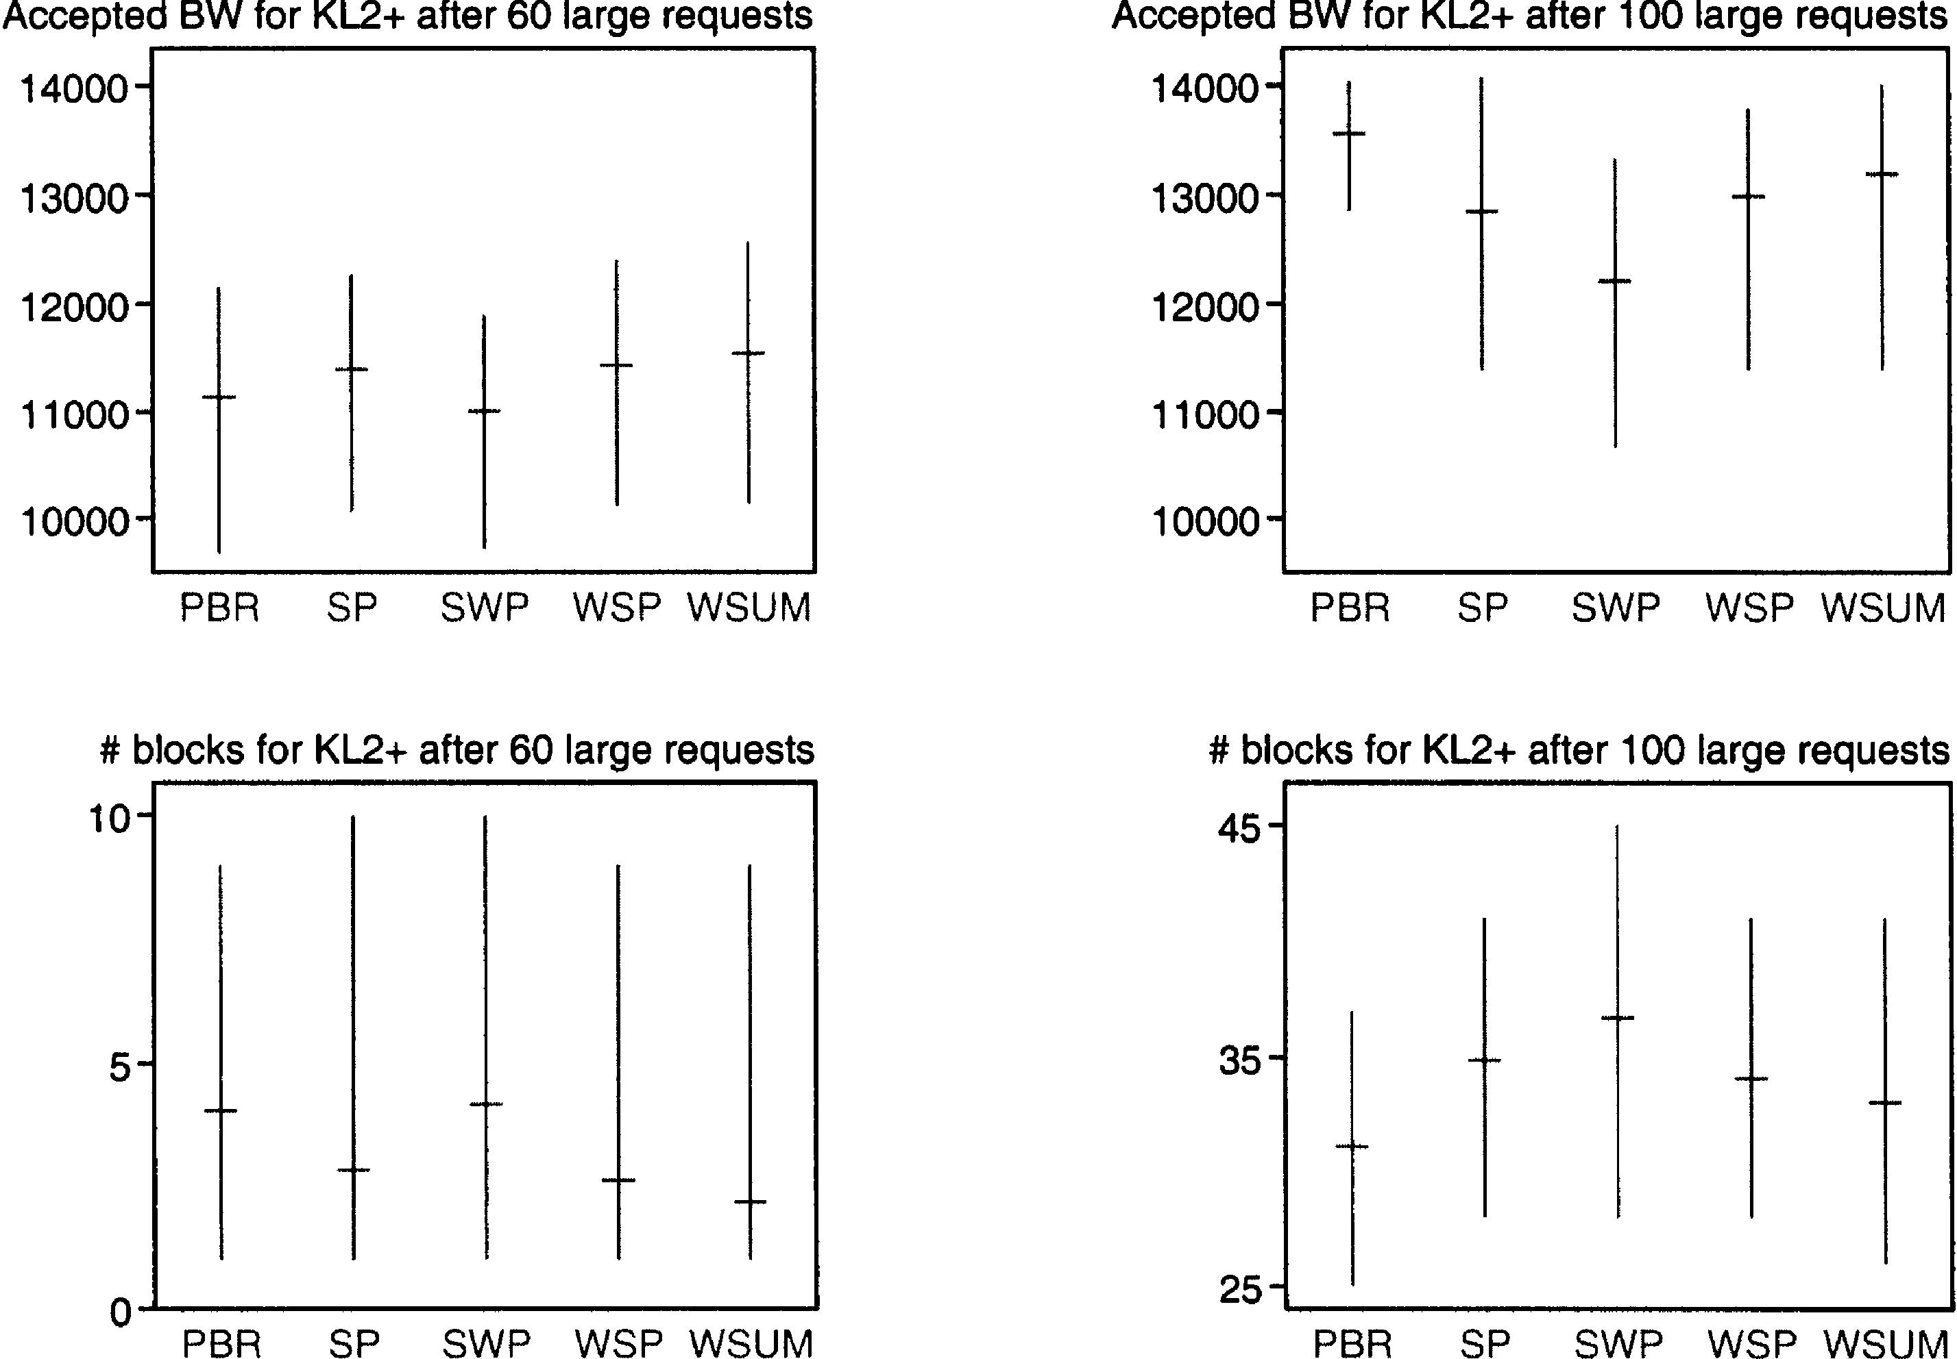
S. Suri et al. / Computer Communications 26 (2003) 351–365

363

Fig. 12. Throughput of accepted requests using a weighted distribution of
demands of 100 – 300 in KL2 ю .
In case a network operator should have signiﬁcantly
unsteady load and thus limiting the usefulness of the proﬁle,
it can take proactive measures. For example, by allocating
some percentage of the link capacity to the classless residue
R(e ) as described in Section 7.2, an ISP gains some
bandwidth that might be ﬂexibly allocated. Alternatively,
self-proﬁling as described in Section 7.5 might be applied to
eliminate the need for manual conﬁguration.

8.8. Route computation time

In addition to the theoretical complexity analysis, we
also conducted measurements on our implementations of
the algorithms. In particular, we measured the average
execution time of several thousand path computations on
network KL2 ю . Although KL2 ю is a rather small
network, it is still sufﬁcient to illustrate the differences in

execution time; we expect the differences to increase
substantially with bigger networks. All results reported
below were run on a 1500 MHz Pentium 4. As the routing
simulator [19] was written with readability and extensibility
in mind, an optimized implementation is expected to
signiﬁcantly improve these results.
As could be expected SP, WSP, and PBR need about the
same time to compute a single path. Average values for
these algorithms are in the range of 110 – 125 ms, corre-
sponding to 8000 – 9000 route requests per second. Our
implementation of SWP requires two iterations of Dijkstra’s
algorithm [20], which results in an average execution time
of 150 ms. Even though SWP executes Dijkstra’s algorithm
twice, the second execution is done on a much-reduced
network that often contains just a single path, increasing the
execution time by far less than a factor of two. The WSUM-
MAX approximation computes several max-ﬂows using
Goldberg and Tarjan’s preﬂow-push algorithm [21]. The
average execution time is 3000 ms, which is more than a
factor of 20 slower than the other algorithms. The initial
computation of PBR’s proﬁle requires 30,000 ms and each
individual path computation requires another 120 ms. Thus,
the initial effort is amortized after about 10 path
computations, after which PBR performs better than the
WSUM-MAX approximation. As MIRA needs to determine
the min-cut after calculating the max-ﬂow, we expect it to
be even slower than WSUM-MAX.

9. Concluding remarks and extensions

We presented a new PBR algorithm for dynamic routing
of bandwidth-guaranteed paths. The online routing phase of

Fig. 13. Performance variation (minimum, average, maximum) using a weighted distribution of demands of 100 – 300 in KL2 ю .

364

S. Suri et al. / Computer Communications 26 (2003) 351–365

the algorithm is as simple and computationally as efﬁcient
as the commonly used minimum-hop routing or the WSP
routing, and it is substantially faster than the recently
proposed minimum interference routing algorithm [2]. Our
algorithm improves network utilization, and accepts more
ﬂows than these other algorithms do, because of its
improved path selection and admission control. The
algorithm takes advantage of quasi-static information
about the network and trafﬁc in an ofﬂine-preprocessing
phase, whose output is used to both guide our online path
selection algorithm as well as impose admission control. In
particular, our algorithm is able to spot potential bottleneck
links that may be in the min cut of ‘clusters‘ of ingress –
egress pairs (cf. CN and DS topologies), as opposed to
single pairs identiﬁed by MIRA. We were unable to perform
a direct comparison with MIRA itself, as not enough
information was available. We consider WSUM-MAX to be
a good approximation of MIRA, even though it may
sometimes return better results.
The multi-commodity preprocessing framework pro-
posed in our paper is quite powerful and admits
numerous extensions and generalization, which can be
used to implement additional policies and requirements.
Just to illustrate the ideas, we mention three such
extensions.
Minimum Service Level. Suppose a service provider
wants to ensure that a bursty trafﬁc class receives at least
a guaranteed maximum level of service. In other words,
while the expected bandwidth of a trafﬁc class i might be
B_{i}, the service provider wants to ensure that at least M_{i}
level of bandwidth is guaranteed during a certain time
period. We can implement this requirement by using a
different cost function in the objective function of our
multi-commodity formulation. The objective function is
augmented by an additive term C which kicks in if more
than B_{i}2 M_{i}units are routed along the excess edge
corresponding to this trafﬁc class.
Imposing Fairness. A ﬂow routing algorithm can
achieve large network utilization, but may unfairly
punish some clients by rejecting a disproportionate
share of their ﬂows. Service providers can implement a
minimum level of fairness by ensuring that a given set of
trafﬁc classes each receives a proportionate share of total
bandwidth. For a trafﬁc class j, we add a^{B}j²M_{j}to our
objective function, which is exponential in the bandwidth
not routed, for a tunable parameter a. This guarantees
that one class receiving an unfairly low bandwidth
allocation leads to a steep cost, and will be avoided.
Combination with Load Proﬁling. If load proﬁles [13] are
available, they can be used to route large requests in order to
minimize call blocking due to insufﬁcient contiguous
bandwidth. We expect it to achieve only minimal improve-
ment under small requests or heavy overload. With large
requests, load proﬁles should result in signiﬁcantly
postponing the ﬁrst block seen on a source-destination pair.

9.1. Future impact

Our framework ﬁts nicely with mechanisms that are
currently being deployed and will be deployed in the future:
Connection-oriented routing, including label-switching
mechanisms such as MPLS, will see a major boost in the
near future, due to the proliferation of VPNs and strict QoS
demands associated with upcoming interactive media
technologies, ranging from voice over IP and video
conferencing to large-scale telepresence and interactive
entertainment.
We further consider PBR to be highly scalable and
adaptive, as the amount of work incurred per ﬂow is linear in
the size of the network, unlike other approaches, which
grow quadratically to cubically with size. Even when
network topologies or demand should change signiﬁcantly,
PBR adapts very well to new situations.
Optical advances, including ﬁber to the curb, will help
create even larger networks with more resources. This will
augment label switching with l-switching, and increase the
demand for routing mechanisms that are efﬁcient in terms of
both link bandwidth and route server CPU usage.
Finally, the increasing mobility of networked devices,
personal networks, and other mobile networks (e.g. cars,
trains, boats, or planes), fast handover and thus rerouting of
ﬂows is key. This is greatly simpliﬁed by the linear time
behavior of the online portion of PBR.

Acknowledgements

Initial work performed at Washington University in St
Louis, partially supported by NSF grant ANI 9813723. An
earlier version of this paper was presented at QoFIS 2001
[1].

References

[1] S. Suri, M. Waldvogel, P.R. Warkhede, Proﬁle-based routing: a new
framework for MPLS trafﬁc engineering, in: F. Boavida (Ed.), Quality
of Future Internet Services, Lecture Notes in Computer Science, vol.
2156, Springer, Berlin, 2001, pp. 138 – 157.
[2] M. Kodialam, T.V. Lakshman, Minimum Interference Routing with
Applications to MPLS Trafﬁc Engineering, Proceedings of IEEE
Infocom, Tel-Aviv, Israel, 2000.
[3] E.C. Rosen, A. Viswanathan, R. Callon, Multiprotocol label switching
architecture, Internet Engineering Task Force RFC 3031 January
(2001).
[4] B. Gleeson, A. Lin, J. Heinane, G. Armitage, A. Malis, A framework
for IP based virtual private networks, Internet Engineering Task
Force, RFC 2764 (2000).
[5] T.V. Lakshman, D. Stiliadis, High Speed Policy-based Packet
Forwarding Using Efﬁcient Multi-Dimensional Range Matching,
Proceedings of ACM SIGCOMM ’98, 1998, pp. 203 – 214.
[6] V. Srinivasan, G. Varghese, S. Suri, M. Waldvogel, Fast and Scalable
Layer Four Switching, Proceedings of ACM SIGCOMM ’98, 1998,
pp. 191 – 202.
[7] V. Srinivasan, S. Suri, G. Varghese, Packet Classiﬁcation Using Tuple

S. Suri et al. / Computer Communications 26 (2003) 351–365

365

Space Search, Proceedings of ACM SIGCOMM ’99, Cambridge, MA,
USA, 1999, pp. 135 – 146.
[8] R. Braden, D. Clark, S. Shenker, RSVP: a new resource reservation
protocol, IEEE Network 7 (9) (1993) 8 – 18.
[9] L. Andersson, P. Doolan, N. Feldman, A. Fredette, B. Thomas, LDP
speciﬁcation, Internet Engineering Task Force, RFC 3036 (2001).
[10] R. Gueґrin, H. Ahmadi, M. Naghshineh, Equivalent bandwidth and its
application to bandwidth allocation in high-speed networks, IEEE
Journal on Selected Areas in Communications 9 (7) (1991) 968 – 981.
[11] R. Gueґrin, A. Orda, D. Williams, QoS Routing Mechanisms and
OSPF Extensions, Proceedings of Second Global Internet Minicon-
ference, 1997.
[12] I. Iliadis, D. Bauer, A New Class of On-Line Minimal Interference
Routing Algorithms, IBM Research Report 3379, IBM Zurich
Research Laboratory, RuЁschlikon, October, 2001.
[13] I. Matta, A. Bestavros, M. Krunz, Load proﬁling based routing for
guaranteed bandwidth ﬂows, European Transactions on Telecommu-
nications 10 (2) (1999).
[14] K. Kar, M. Kodialam, T. Lakshman, Minimum interference routing of
bandwidth guaranteed tunnels with MPLS trafﬁc engineering

applications, IEEE Journal of Selected Areas in Communications 18
(12) (2000) 2566 – 2579.
[15] R.K. Ahuja, T.L. Magnanti, J.B. Orlin, Network Flows: Theory,
Algorithms, and Applications, Prentice-Hall, Upper Saddle River, NJ,
USA, 1993.
[16] M.R. Garey, D.S. Johnson, Computers and Intractability: a Guide to
the Theory of NP-Completeness, W.H. Freeman and Company, New
York, 1979.
[17] E.W. Dijkstra, A note on two problems in connection with graphs,
Numerische Mathematik 1 (1959) 269 – 271.
[18] D. Bauer, A new minimum-interference routing algorithm based on
ﬂow maximization, IEE Electronics Letters 38 (8) (2002) 364 – 365.
[19] S. Cech, A Route Server for Constraint-Based Routing in MPLS,
Master’s Thesis, UniversitaЁt Klagenfurt, Austria, January 2002.
[20] Q. Ma, P. Steenkiste, Onpath Selection for Trafﬁc with Bandwidth
Guarantees, Proceedings of IEEE International Conference on
Networking Protocols (ICNP’97), 1997, pp. 191 – 202.
[21] A.V. Goldberg, R.E. Tarjan, A New Approach to the Maximum Flow
Problem, Proceedings of the Eighteenth Annual ACM Symposium on
Theory of Computing, 1986, pp. 136 – 146.

